**D10.4 Report on Use Cases, Requirements, Metadata and Interoperability of WP 10**

**Document information Summary**

|  |  |
| --- | --- |
| **Date** | 31 March 2018 |
| **Document title:** | Report on Use Cases, Requirements, Metadata and Interoperability of WP 10 |
| **Leader Partner** | UBI |
| **Main Author(s):** | Paul Crocker |
| **Contributing author(s):** | UBI, ROB, IMO, CNRS, INGV, GOP, NOA |
| **Reviewer(s):** |  |
| **Approved by:** |  |
| **Target audiences:** | EPOS |
| **Keywords:** |  |
| **Deliverable nature:** |  |
| **Dissemination level:** |  |
| **Delivery date:** | 31-03-2018 |
| **Version:** | 1.0 |

**TABLE OF CONTENTS**

1. Introduction 3

2. Priority List of DDSS’s 4

2.1. Data and Metadata Categories 7

2.2 Short description of TCS services and their current status 8

2.3 The Database Scheme 10

3. Data Management Plan (DMP) 11

4. Use cases 12

5 Interoperability 27

6. Conclusion 30

# 1. Introduction

The GNSS EPOS-TCS will be composed of distinct services that will permit the access to GNSS data and data products by the different stakeholders (scientific community, technical users). Besides the dedicated services being implemented, GNSS TCS will rely on the EUREF Permanent Network (EPN) contribution that will also provide data, data products and the definition of a consistent reference frame. Each service will be available through a dedicated portal with whom the end user interacts directly, or via the EPOS-ICS. The two dedicated EPOS portals each give access to data (products) through a distributed set of data (products) centers and link to the ICS. EPN data and products are integrated as data (products) nodes interfacing with the dedicated data and product portals as well as the ICS. A dedicated software package (GLASS) is being developed to manage the consistent access to the data and products.

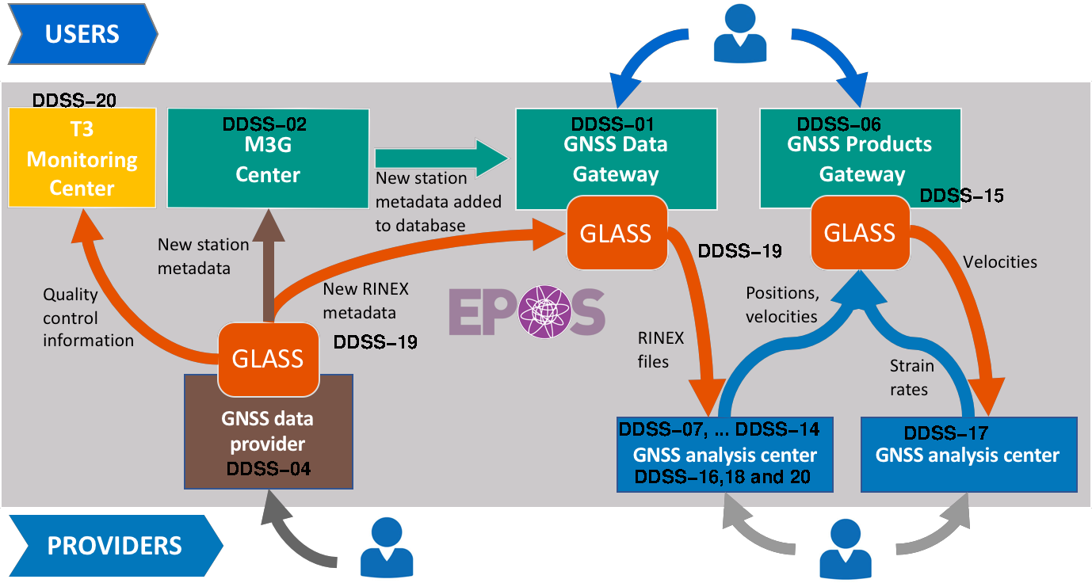

*Figure 1. The parts that form TCS GNSS Data & Products together with their interactions.*

# 2. Priority List of DDSS’s

|  |
| --- |
| **DDSS type**  **Data** Dissemination of GNSS Data (standard software / meta-data submission center / dissemination of data / data validation & monitoring) |
| **Format(s) of the data / data products (if applicable)**   * RINEX 30 sec daily data * RINEX 1 sec hourly data * METADATA (T1 - relative to station attributes; T2 - relative to data location , T3 - relative to data quality) |
| **Metadata standard used**  Database (binary) for metadata maintenance  XML for metadata transference |
| **APIs used to provide discovery and access to the DDSS**   * web browser-based user interface for searching stations and data files * site (monument and/or station) and instrument metadata, in a variety of formats * URLs to download data files * web services to allow access to all services from the command line, or with a browser, or batch jobs * client program for programmatic interaction with a repository, typically to download multiple RINEX files |
| **Authentication, Authorization, Accounting Infrastructure (AAAI)**  We consider that AAAI policy is necessary. We intend to follow the EPOS general approach for ICS such as UNITY-IDM. |
| **Data policy**  The normal policy will be that data will be available as soon as the files are uploaded to the system after validation. Grace periods can be considered for very special cases (e.g., dedicated projects). |
| **Other technical details**  A dedicated consistent software package (GLASS) is being developed and it will be implemented to manage all different aspects of data access, storage, validation and dissemination. |
| **Roadmap for implementation**   * GLASS standard software prototype - 06-2016 * T1 (site log) metadata submission center - 03-2017 * dissemination of data - 12-2016 * data validation & monitoring - 06-2018 |

|  |
| --- |
| **DDSS type**  **Products** Dissemination of GNSS Products (GNSS observations - consistent daily, weekly positions solutions / consistent daily, weekly positions solutions - stations positions, velocities and time series / GNSS station positions, velocities and time series - strain rate maps / dissemination of products) |
| **Format(s) of the data / data products (if applicable)**   * SINEX - Daily solutions for PPP, DD and densified solutions * TINEX, STCD, PBO,MIDAS - Time Series for PPP, DD and densified solutions * SINEX and SSC file - Velocity files for PPP, DD and densified solutions * ASCII format including uncertainties and two binary files (grd Global Mapping Tools file), one for Exx and one for Eyy for Strain-rate maps. |
| **Metadata standard used** Database (binary) for metadata maintenance.  JSON/XML for metadata transference. |
| **APIs used to provide discovery and access to the DDSS** web browser-based user interface for searching product files   * coordinates and velocities for stations in a variety of formats * velocity and strain rate fields in a variety of formats * URLs to download data files * web services to allow access to all services from the command line, or with a browser, or batch jobs * client program for programmatic interaction with a repository, typically to download multiple Product files |
| **Authentication, Authorization, Accounting Infrastructure (AAAI)**  We consider that AAAI policy is necessary. We intend to follow the EPOS general approach for ICS such as UNITY-IDM. |
| **Data policy**  The normal policy will be that all products produced by EPOS will be available as soon as the files are uploaded to the system after validation. |
| **Other technical details**  A dedicated consistent software package (GLASS) is being developed and it will be implemented to manage all different aspects of data access, storage, validation and dissemination. |
| **Roadmap for implementation**   * Station positions, velocities and time series - 12-2017 * Velocity and strain rate maps - 02-2018 |

|  |
| --- |
| **DDSS type**  **EUREF (EPN)** Dissemination of GNSS Data & Products (see previous tables). Realization of the Reference Frame. |
| **Format(s) of the data / data products (if applicable)**   * Data & Data Products (see previous tables) * SINEX - Reference Frame realization |
| **Metadata standard used** Database (binary) for metadata maintenance  JSON/XML for metadata transfer (new GML standard is under development at IGS) |
| **APIs used to provide discovery and access to the DDSS** (see previous tables) |
| **Authentication, Authorization, Accounting Infrastructure (AAAI)**  Open access |
| **Data policy** Open access |
| **Other technical details**  The adoption of GLASS is being considered, but unsure. Probably dedicated software will have to be developed due to the fact that the EPN structure is different from the underlying structure of GLASS. |
| **Roadmap for implementation**   * EPN - already implemented, interface with data and product gateway and ICS not yet implemented |

|  |
| --- |
| **DDSS type** GLASS (Software package) |
| **Format(s) of the data / data products (if applicable)** |
| **Metadata standard used** |
| **APIs used to provide discovery and access to the DDSS**  Package integrating different computational applications (database, web-services, scripting, independent software) |
| **Authentication, Authorization, Accounting Infrastructure (AAAI)**  We intend to follow the EPOS general approach for ICS. Unity, NGINX Proxy etc. |
| **Data policy**  Registered user. |
| **Other technical details** |
| **Roadmap for implementation**   * GLASS Prototype Implementation currently developed and being tested |

In order to be able to identify more precisely the individual priority DDSS elements the following table is presented:

Table 1: Current list of priority DDSS’s

|  |  |  |
| --- | --- | --- |
| **DDSS identifier** | **Service Description** | **Remark/Description** |
| *Data Dissemination* |  |  |
| WP10-DDSS-001 | Data.GNSS.Gateway | Portal |
| WP10-DDSS-002 | Data.GNSS.SiteMetadataSubmission | QC Meta Data |
| WP10-DDSS-004 | Data.GNSS.PanEur.Repositories | Data Repository |
| WP10-DDSS-020 | Data.GNSS.QualityMonitoring | Portal / QC |
| *Product Dissemination* |  |  |
| WP10-DDSS-006 | Products.GNSS.Gateway | Portal |
| WP10-DDSS-007 | Products.GNSS.PPP.Position | Analysis Centre |
| WP10-DDSS-008 | Products.GNSS.DD.Position | Analysis Centre |
| WP10-DDSS-009 | Products.GNSS.PPP.TimeSeries | Analysis Centre |
| WP10-DDSS-010 | Products.GNSS.DD.TimeSeries | Analysis Centre |
| WP10-DDSS-011 | Products.GNSS.Combined.Position | Analysis Centre |
| WP10-DDSS-012 | Products.GNSS.DD.Velocity | Analysis Centre |
| WP10-DDSS-013 | Products.GNSS.PPP.Velocity | Analysis Centre |
| WP10-DDSS-014 | Products.GNSS.Combined.Velocity | Analysis Centre |
| WP10-DDSS-015 | Products.GNSS.Validation.Pos_Vel | Quality Control |
| *EUREF Dissemination* |  |  |
| WP10-DDSS-016 | Products.EUREF.Combined.Positions | Analysis Centre |
| WP10-DDSS-018 | Products.EUREF.ReferenceFrame | Analysis Centre |
| WP10-DDSS-022 | Products.EUREF.Densification | Analysis Centre |
| *Software* |  |  |
| WP10-DDSS-019 | Software.GNSS | Software |

# 2.1. Data and Metadata Categories

WP10 has categorized its data and metadata into the following categories:

* Type 0 Definition of the Topology of the EPOS-GLASS network system (Nodes and data Centers)
* Type 1 GNSS Station and Site Information
* Type 2 GNSS RINEX File Information
* Type 3 Data quality control metrics.
* Type 4 GNSS Time Series Products
* Type 5 GNSS Velocity Field Products
* Type 6 GNSS Strain Rate Map products

# 2.2 Short description of TCS services and their current status

WP10 contains two DDSS (**WP10-DDSS-001** and **WP10-DDSS-006**) that represent deployed Web Portals that contain GUI’s for accessing the underlying data and products as well as the Rest Web Services that enable programmatic interaction of the ICS with WP10 data and products. **WP10-DDSS-001** and **WP10-DDSS-006** will run the web services that make all WP10 data and products (generated by other DDSS) available to the ICS. **WP10-DDSS-002** is the other Web Portal where all new information concerning all new EPOS Sites/Stations is entered and validated as well as all underlying guidelines for station managers.

***READY***

**WP10-DDSS-001** Data Portal

**WP10-DDSS-002** Station Metadata Management Portal

**WP10-DDSS-006** Products Portal

**WP10-DDSS-004[1]** Pan-European data repositories for raw GNSS data.

**WP10-DDSS-007** **and** **08** represent daily positions of GNSS stations using two different calculation mechanisms (PPP and DD, respectively)

**WP10-DDSS-009, 10 and 11** represent dedicated time series products for GNSS stations using different calculation mechanisms and agencies.

**WP10-DDSS-012, 13 and 14** represent dedicated velocity products for GNSS stations using different calculation mechanisms and agencies.

**WP10-DDSS-015** tasks related to GNSS positions and velocities Quality Monitoring

**WP10-DDSS-016** this is the GNSS Products (weekly-comb.positions) from EUREF

**WP10-DDSS-018** This is the EUREF Reference Frame Service, which includes time-series, reference positions and velocities.

**WP10-DDSS-019[2]** This task relates to all the WP10 Software to Access to data/products (GLASS)

***IN DEVELOPMENT***

**WP10-DDSS-017** Tasks related to the computation of GNSS Strain Rate Maps products

**WP10-DDSS-020** Tasks related to the future Data Quality Monitoring service

**WP10-DDSS-021** Tasks related to the future real-time GNSS service.

# 2.3 The Database Scheme

The database scheme, shown below, describing the data and metadata types and relations can be found at the following link <https://gitlab.com/gpseurope/database>. This can be accessed by registered users and contains the most up-to-date version.

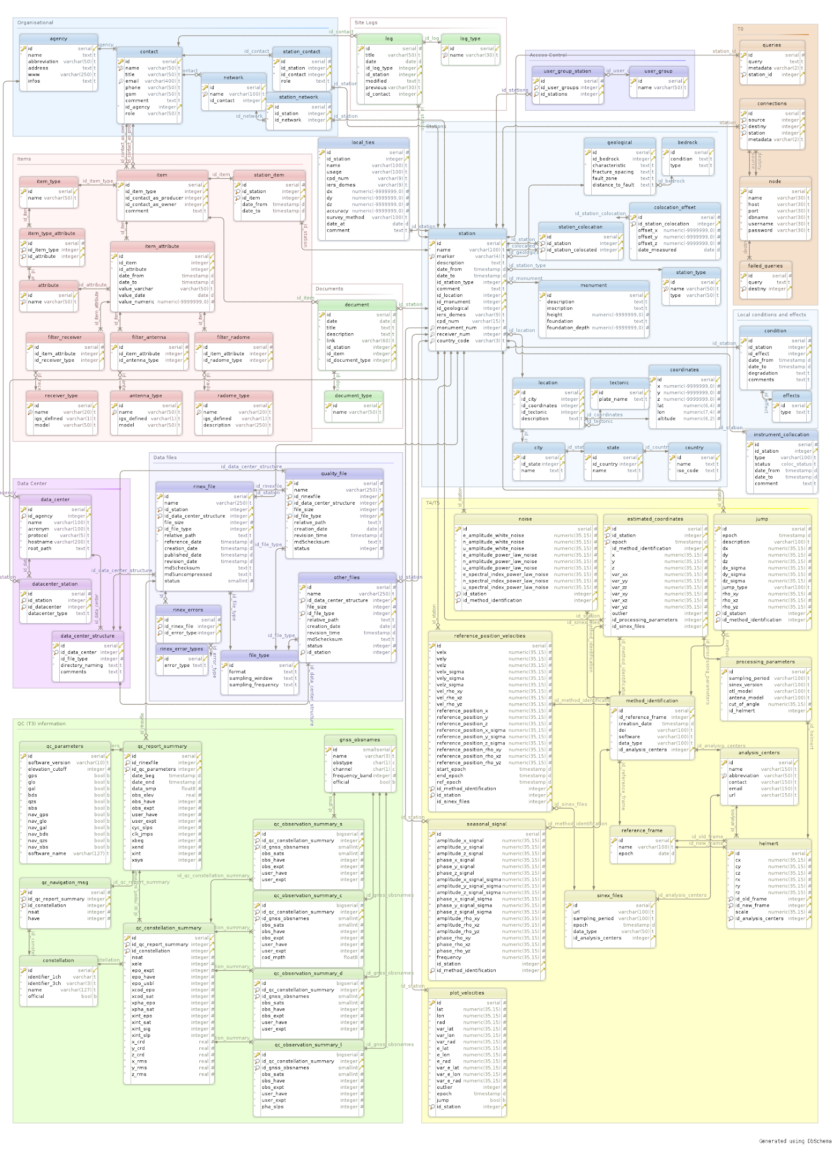

WP10 Data and Metadata database

# 3. Data Management Plan (DMP)

The DMP (Data Management Plan) for each DDSS will be discussed and finalized during the incoming months. This also needs to take into account the EU General Data Protection Regulation (GDPR) data privacy regulations (https://www.eugdpr.org/). Nevertheless, some aspects have been already discussed:

**i) Data Access Policy**

The normal policy will be that data and data products will be available as soon as the files are uploaded to the system after validation. Grace periods can be considered for very special cases (e.g., dedicated projects).

**ii) Data storage and maintenance responsibility**

The first responsibility to storage and maintain the GNSS data and products will be of the network owner's (data) and producers (products). In addition, the GNSS EPOS-TCS is developing dedicated software and services to guarantee redundancy on the data and products storage.

**iii) Data curation responsibility**

GNSS EPOS-TCS intends to follow the methodologies to be adopted by EPOS for curation. In addition, it is supporting other projects being submitted to EU on this particular topic which is extremely important to preserve historical data.

**iv) Data management and governance structure**

To be defined in the coming months.

**v) Financial commitment securing the operational costs**

To be defined in the coming months. Several groups already committed to support long-term operations.

# 4. Use cases

|  |
| --- |
| **Use case name/topic**: A GNSS network manager wants to add/remove a station to/from his GNSS network contributing to EPOS |
| **Use case domain** This use case is: *discipline-oriented, namely focusing on the discipline of geodesy* |
| **Use case description**  *As a <GNSS network manager> I want to <add/remove a station to my network contributing to EPOS> so that I can <include the GNSS stations into the EPOS network and share its data with the community>.* |
| **Actors involved in the use case**   * *System user – data provider* * GNSS Network Manager |
| **Priority** Medium |
| **Pre-conditions** GNSS network manager has valid login/password for Site log submission center associated with a GNSS network name. |
| **Flow of events – user view**   1. < *GNSS network manager* > *logs into* *<Site log submission center> using GUI* 2. < *GNSS network manager* > *enters an ”update (or create) OC (operational center) form” request at the GUI of the <Site log submission center>* 3. < *GNSS network manager* > *updates* (*or* *fills) the OC form with a list of stations and the type of data he will submit* 4. < *GNSS network manager* > *receives confirmation of responsibility for the list of stations entered in the OC form* |
| **System workflow - system view**   1. *The user interface receives login information* 2. *The user interface receives OC updates* 3. *The user input is validated at the <Site log submission center>* 4. *The user interface connects to its internal database and adds the information on GNSS station responsibility* |
| **Other Requirements** GNSS network manager has valid login/password for Site log submission center  associated with a GNSS network name. |

|  |
| --- |
| **Use case name/topic**: *Updating GNSS station information (T1 metadata) at the <Site log submission center>* |
| **Use case domain** This use case is: *discipline-oriented, namely focusing on the discipline of geodesy* |
| **Use case description**  *As a <GNSS station manager> I want to <update the information on the equipment installed at my GNSS station> so that I can <keep track of this hardware change at the station and disseminate this information to the rest of the community>.* |
| **Actors involved in the use case**   * *System user – data provider*   + *GNSS station manager* |
| **Priority** *Medium* |
| **Pre-conditions**  *User (station manager) must have the permission to update the station information and must be logged in.* |
| **Flow of events – user view**   1. < *GNSS station manager*> *selects the station for which he wants to update the information at the <Site log submission center>* 2. < *GNSS station manager* > *enters the information in the GUI of the <Site log submission >* 3. < *GNSS station manager*> *receives confirmation/rejection of the new input based on several validation criteria* 4. < *GNSS station manager* > *receives a file containing all the GNSS station information* |
| **System workflow - system view**   1. *The user interface receives the input* 2. *It validates the input* 3. *It connects to its internal database and updates the validated information* 4. *It produces a file based on the new database content* |
| **Post-conditions** *The information is sent to the EPOS GNSS data gateway.* |
| **« Used » Use Cases** A GNSS network manager wants to add/remove a station to/from his GNSS network contributing to EPOS |

|  |
| --- |
| **Use case name/topic**: *Iberia GNSS velocity field* |
| **Use case domain** This use case is: *Multi-discipline-oriented, namely focusing on the discipline of Geodynamics* |
| **Use case description**  A search for all computed GNSS derived velocities in Iberia based only on high quality GNSS time series longer than 3 years |
| **Actors involved in the use case**   * *Scientists interested in plate tectonics in Iberia* * GNSS data providers, * WP10 Product gateway * WP10 analysis centres who compute GNSS positions and the associated velocities |
| **Priority** *High* |
| **Pre-conditions**  User should be logged in with some EPOS authentication system (shibboleth, eduroam, google etc..) |
| **Flow of events – user view**   1. User selects rectangle to define geographic region for which GNSS data and products are required on GNSS product gateway. 2. User refines search to limit results for stations that have time span longer than 3 years and also stations which provide high quality daily solutions - hence this search combines GNSS data availability and GNSS products. 3. A list of URL's to files with velocity solutions for the stations is returned. |
| **System workflow - system view**   1. The user interface receives the input of the geographic region and quality metrics 2. It connects to the WP10 Product Gateway preforms a search on the required data 3. A script is produced containing the URL's to files with velocity solutions. 4. The user runs the script (inside the work-flow or independently) |
| **Post-conditions** The Request should be logged so that the user can retrieve and rerun the workflow - possibly with different conditions. |
| **Other Requirements** Data Should be Flagged as Public. Data should be retrieved within a pre-defined (user configurable) time period else search is cancelled on sub-node |

|  |
| --- |
| **Use case name/topic**: Compute the velocity of a station using external information to detect co-seismic offsets |
| **Use case domain** This use case is: *Multi-discipline-oriented, namely in the area of Velocity computations* |
| **Use case description**  *As a <time-series analyst> I want to <compute the secular motion of the stations> so that I can <compute strain rates>.* |
| **Actors involved in the use case**   * *Time-series analyst* * GNSS data providers, * Seismic catalogue providers (e.g., WP08) * WP10 Product Gateway * WP10 analysis centres who compute GNSS positions |
| **Priority** *Medium* |
| **Pre-conditions** *User must have logged in.* |
| **Flow of events – user view**   1. User selects rectangle to define geographic region for GNSS stations of interest. 2. User retrieves daily coordinates for the GNSS stations of interest from the WP10 Product Gateway 3. User retrieves seismic catalogue with seismic events nearby the region of interest. 4. User computes the offsets for the epoch of the events. 5. User provides updated information on the co-seismic offsets and secular velocities to the WP10 Product Gateway. |
| **System workflow - system view**   1. The user interface receives the input of the geographic region and quality metrics 2. It connects to the EPOS ICS Gateway to preform a search on the required data 3. A script is produced containing the URL's to files with time-series and catalogue of seismic events. 4. The user runs the script (inside the work-flow or independently) 5. The user uploads new solutions to the EPOS Product Gateway. |
| **Post-conditions** The Request should be logged so that the user can retrieve and rerun the workflow - possibly with different conditions. |

|  |
| --- |
| **Use case name/topic**: *Obtaining GNSS data for the estimation of Volcano deformation* |
| **Use case domain** This use case is: *Multi-discipline-oriented, namely focusing on the discipline of volcanology.* |
| **Use case description**  *As a <researcher of volcanology> I want to <access GNSS data> so that I can <estimate short-term deformations pre-, co- and/or volcanic eruptions>* using high-rate (1Hz) data. |
| **Actors involved in the use case**   * System user – Researchers (e.g., WP11) * GNSS data providers (e.g., WP11 networks) * WP10 Data Gateway |
| **Priority** *Medium* |
| **Pre-conditions**  User should be logged in with some EPOS authentication system (shibboleth, eduroam, google etc..) |
| **Flow of events – user view**   1. *<volcanogic researcher> chooses location to study* 2. *<volcanogic researcher> chooses the GNSS stations and time interval of the record* 3. *<volcanogic researcher> downloads the desired data (hourly files at 1Hz) for deformation calculation* |
| **System workflow - system view**   1. *The user interfaces receives the input: location (coordinates) and time interval* 2. *It connects to the database and searches records on station located on the coordinates for the specified time period* 3. *The user interface delivers a list of stations with the desired data* |
| **Post-conditions**  The Request should be logged so that the user can retrieve and rerun the workflow - possibly with different conditions. |

|  |
| --- |
| **Use case name/topic**: Volcano velocity/deformation field estimation for multidisciplinary modelling |
| **Use case domain** This use case is: *discipline-oriented, namely focusing on volcano monitoring* |
| **Use case description**  For < volcano monitoring> I want to <access GNSS deformation/velocity estimates> so that I can < use long/medium term deformation around a volcano for multidisciplinary modelling of volcanic processes (comping with InSAR, seismic ...)> derived from 30 s data. |
| **Actors involved in the use case**   1. *System user – Researchers/monitoring agency (e.g. WP11)* 2. *GNSS data providers (e.g. WP11 networks)* 3. *WP10 Data Gateway* 4. *other WP TCS's* 5. WP10 analysis centres who compute GNSS positions and the associated velocities 6. possibly other EPOS software and computing facilities |
| **Priority** Medium |
| **Pre-conditions** User should be logged in with some EPOS authentication system |
| **Flow of events – user view**   * User selects rectangle to define geographic region for which GNSS data and products are required on GNSS product gateway. * User refines search to limit results for stations to fit the appropriate time spans * A list of URL's to files with velocity solutions for each time window for the stations selected is returned to be joint with other data types for further processing * joint source modelling of multidisciplinary data for a particular volcanic system |
| **System workflow - system view**   * The user interface receives the input of the geographic region * It connects to the WP10 Product Gateway preforms a search on the required data * A script is produced containing the URL's to files with velocity solutions. * The user runs the script (inside the work-flow or independently) |
| **Post-conditions** Request should be logged so the user can retrieve and rerun the workflow (with different conditions). |

|  |
| --- |
| **Use case name/topic**: *co-seismic displacements associated with a Mw7 earthquake in Greece* |
| **Use case domain** *Multi-discipline-oriented, namely focusing on the discipline of geophysics.* |
| **Use case description**  A search for all computed GNSS derived position time series that include the date of the earthquake within a circle of 300km around the epicenter |
| **Actors involved in the use case**   * *Scientists interested in active tectonics studies* * GNSS data providers, * WP10 Product gateway * WP10 analysis centres who compute GNSS positions time series |
| **Priority** *High* |
| **Pre-conditions** User should be logged in with some authentication system (shibboleth, eduroam, google etc..) |
| **Flow of events – user view**   1. User selects a circle on a geographic region for which GNSS data and products are required on GNSS product gateway. 2. User refines search to limit results for stations that spans the day of the earthquake - hence this search combines GNSS data availability and GNSS products. 3. A list of URL's to files with daily solutions for the stations is returned. |
| **System workflow - system view**   1. The user interface receives the input of the geographic region and quality metrics 2. It connects to the WP10 Product Gateway performs a search on the required data 3. A script is produced containing the URL's to files with daily solutions. 4. The user runs the script (inside the work-flow or independently) |
| **Post-conditions** The Request should be logged so that the user can retrieve and rerun the workflow - possibly with different conditions. |

|  |
| --- |
| **Use case name/topic**: *GNSS time series at the Eurasia-Nubia plate boundary in Italy* |
| **Use case domain** *Multi-discipline-oriented, namely focusing on the discipline of geophysics.* |
| **Use case description**  A search for all computed GNSS derived position time series longer than 3 years in Italy |
| **Actors involved in the use case**   * *Scientists interested in active tectonics studies* * GNSS data providers, * WP10 Product gateway * WP10 analysis centres who compute GNSS positions time series |
| **Priority** *High* |
| **Pre-conditions**  User should be logged in with some EPOS authentication system (shibboleth, eduroam, google etc..) |
| **Flow of events – user view**   1. User selects a box on a geographic region for which GNSS data and products are required on GNSS product gateway. 2. User refines search to limit results for stations that have time span longer than 3 years and also stations which provide high quality daily solutions - hence this search combines GNSS data availability and GNSS products. 3. A list of URL's to files with daily solutions for the stations is returned. |
| **System workflow - system view**   1. The user interface receives the input of the geographic region and quality metrics 2. It connects to the WP10 Product Gateway performs a search on the required data 3. A script is produced containing the URL's to files with daily solutions. 4. The user runs the script (inside the work-flow or independently) |
| **Post-conditions**  The Request should be logged so that the user can retrieve and rerun the workflow - possibly with different conditions. |

|  |
| --- |
| **Use case name/topic**: *GNSS metadata download for GNSS data analysis* |
| **Use case domain** *Multi-discipline-oriented, namely focusing on the discipline of geodesy.* |
| **Use case description**  A search for the metadata (e.g. site logs, a priori station information) for each scientific GNSS analysis software. |
| **Actors involved in the use case**   * *Scientists interested in GNSS data analysis* * GNSS data providers, * WP10 data gateway * WP10 analysis centres who compute GNSS positions time series |
| **Priority** *Medium* |
| **Pre-conditions**  User should be logged in with some EPOS authentication system (shibboleth, eduroam, google etc..) |
| **Flow of events – user view**   1. User selects a box on a geographic region or a list for which GNSS metadata are required on GNSS data gateway. 2. A list of URL's to files with site logs for the stations is returned. |
| **System workflow - system view**   1. The user interface receives the input of the geographic region and/or of the input list 2. It connects to the WP10 Product Gateway performs a search on the required data 3. A script is produced containing the URL's to files with site logs. 4. The user runs the script (inside the work-flow or independently) |
| **Post-condition** The Request should be logged so that the user can retrieve and rerun the workflow - possibly with different conditions. |

|  |
| --- |
| **Use case name/topic**: Compute the velocity of a station to detect post-seismic motion |
| **Use case domain**: *Multi-discipline-oriented, namely in the area of Velocity computations* |
| **Use case description** *As time-series analysts we want to compute the motion of GNSS stations before/after large earthquakes so that we can measure post-seismic motion. The stations are located in the central Ionian region, Greece. This area has been repeatedly subjected to strong ground shaking due to the proximity of the islands to the 140-km long CTF (Cephalonia Transform Fault). The 100-km long NNE-SSW fault zone accommodates the relative motion of the Apulia (Africa) and Aegean (Eurasia) lithospheric plates, and has a GPS slip-rate bracketed between 10 and 25 mm/yr. During the last 15 years this fault system generated 4 strong events that caused ground deformation of the order of 1-40 cm.* |
| **Actors involved in the use case**   * *Time-series analysts (NOA, NKUA, NTUA, AUTH)* * GNSS data providers (NOA, NKUA, CRL-WP09) * Seismic catalogue providers (e.g., WP08) * WP10 Product Gateway * WP10 analysis centres who compute GNSS positions * *Scientists interested in active tectonics studies* |
| **Priority** *Medium* |
| **Pre-conditions** *User must have logged in.* |
| **Flow of events – user view**   1. User selects rectangle to define geographic region for GNSS stations of interest. 2. User retrieves daily coordinates for the GNSS stations of interest from the WP10 Product Gateway 3. User retrieves seismic catalogue with seismic events nearby the region of interest. 4. User computes the co-seismic offsets for the epoch of the events. 5. User estimates the station velocities before / after for the epoch of the events. 6. User provides updated information on the secular velocities to the WP10 Product Gateway. |
| **System workflow - system view**   1. The user interface receives the input of the geographic region and quality metrics 2. It connects to the EPOS ICS Gateway to perform a search on the required data 3. A script is produced containing the URL's to files with time-series and catalogue of seismic events. 4. The user runs the script (inside the work-flow or independently) 5. The user uploads new solutions to the EPOS Product Gateway. |
| **Post-conditions** The Request should be logged so that the user can retrieve and rerun the workflow - possibly with different conditions. |

|  |
| --- |
| **Use case name/topic**: Access to GNSS data quality results for monitoring purposes |
| **Use case domain** This use case is discipline-oriented, namely focusing on the discipline of geodesy. |
| **Use case description** *As a <Data-monitoring-center> collect quality monitoring information so that I can monitor the quality of disseminated GNSS data and prepare a feedback to the data providers and support for data users.* |
| **Actors involved in the use case**.   * GNSS data monitoring center * GNSS data dissemination system (in particular data gateway providing access to T3 metadata) * GNSS data providers (local node operators, preparation of T3 metadata) |
| **Priority** High |
| **Pre-conditions** GNSS data providers (local node operators) generate and populate T3 metadata for all RINEX files in their repositories using standard tools. T1 metadata are correct and synchronized. |
| **Flow of events – user view**   1. <Data-monitoring-center> updates the list of available stations (T1 metadata). 2. <Data-monitoring-center> collects T3 metadata for all available stations and requested recent period. The collection is foreseen using data dissemination system (via data gateway or intermediate gateway 3. <Data-monitoring-center> performs a visualization of data quality and, alternatively, another actions. |
| **System workflow - system view**   1. <Data-gateway or intermediate-gateway> receives requests for T3 metadata collection for each station (in sequence or simultaneously, depends on both temporal and spatial domains of the request) 2. <Data-gateway> connects to local repository nodes in order to provide requested T3 metadata. The results will be provided to the <Data-monitoring-center> in requested format (JSON, XML, ..) |
| **Post-conditions** : The concept of flexible data redundancy is adopted. |
| **« Used » Use Cases**   * Specific or subset of T3 data queries and search can be re-used by any user searching a minimum quality for GNSS stations – e.g. Multi-GNSS system (GPS, GLONASS, Galileo, BeiDou, SBAS or QZSS), type of observations or frequencies, etc. * Remote file comparison in support of a file redundancy with a smart selection |

|  |
| --- |
| **Use case name/topic**: *Remote file comparison in support of a file redundancy with a smart selection* |
| **Use case domain** This use case is: *Discipline-oriented, namely focusing on the discipline of geodesy.* |
| **Use case description** *As a <GNSS-user> I want to download data optimal to my request. As a <GNSS-data-gateway> I want to support data download in a smart way using automated decision.* |
| **Actors involved in the use case**   * *Data user* * *Data providers* * *Data gateway* |
| **Priority:** *Medium* |
| **Pre-conditions**: |
| **Flow of events – user view**   1. <Data-user> selects a subset of GNSS data files for his analysis using GNSS data gateway. 2. <Data-user> requests data download in a smart (predefined options) or in an interactive way. 3. <Data-user> obtains optimally selected files automatically or is asked shown indication on basic file characteristics (tbd, e.g. number of observations, number/list of observation types, number/list of GNSS |
| **System workflow - system view**   1. *<Data-gateway> gets the user request on data selection.* 2. *<Data-gateway> communicates with local repositories and requests specific T3 metadata* 3. *<Data-gateway> gives automatically selected files (using predefined options) or provide an interactive selection for data download to the user* |

|  |
| --- |
| **Use case name/topic:** Compute Eurasian strain rates from EPOS stations velocities |
| **Use case domain:** *Multi-discipline-oriented, namely in the area of strain-rate computations* |
| **Use case description:** *The user will produce strain-rate maps for Eurasia (principal strain axes – dilatation rate – shear strain rate - rotation rate) using a) the VISR and STIB algorithms recommended by EPOS or b) their own algorithm.* |
| **Actors involved in the use case**   * *Strain rate analysts (NOA, NKUA, NTUA, AUTH, INGV, LM etc.)* * *GNSS data providers (NOA, NKUA, CRL-WP09, INGV, UBI etc.)* * *WP10 Product Gateway* * *WP10 analysis centres who compute GNSS positions and velocities* |
| **Priority:** *Medium* |
| **Pre-conditions:** *User must have logged in.* |
| **Flow of events – user view**   1. User selects rectangle to define geographic region for GNSS stations of interest. 2. User retrieves horizontal velocities for GNSS stations of interest from the Product Gateway 3. User computes the strain-rates on his computer or on-line using the EPOS tools. 4. User provides updated information on the strain-rates to the WP10 Product Gateway. |
| **System workflow - system view**   1. The user interface receives the input of the geographic region and quality metrics 2. It connects to the EPOS ICS Gateway to perform a search on the required data 3. A script is produced containing the URL's to files with station velocities. 4. The user runs the script (inside the work-flow or independently) 5. The user uploads new solutions to the EPOS Product Gateway. |
| **Post-conditions:** *The Request should be logged so that the user can retrieve and rerun the workflow - possibly with different conditions.* |
| **Other Requirements:** *The Request depends on data availability so that the result is scientifically meaningful. For example, the user will use velocity data from >200 stations in Italian Peninsula (which will be available sometime in the future).* |

# 

# 5 Interoperability

Interoperability is based on the GLASS Application Programming Interface for making queries over the station and product metadata. IT’s a REST API documented using swagger. The API swagger documentation can be found at either the WP10 Data Gateway (DDSS 1) Or the WP10 Product Portal (DDSS 6)   
The interoperability between ICS and all GNSS data and products repositories will be done through the WP10 Gateways, DGW (Data Gateway) and the PGW (Products Gateway), which will be located in France and Portugal, respectively. No direct (ICS) link will exist to the local or regional WP10 repositories.

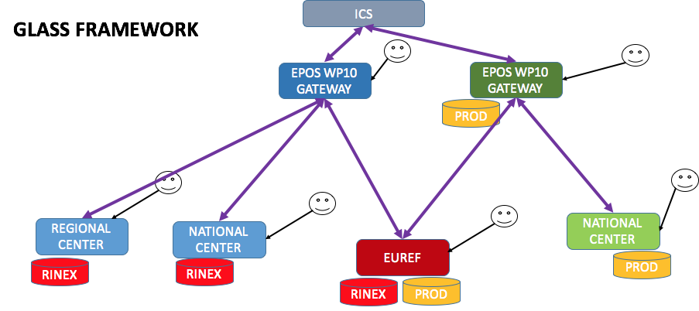

The WP10 interoperability with TCS-ICS was successfully demonstrated at the 2017 Prague meeting using the following use case: “ Search for “Epos Data” in a geographical region containing an interesting seismic activity. The region was Italy and the Year 2009.”

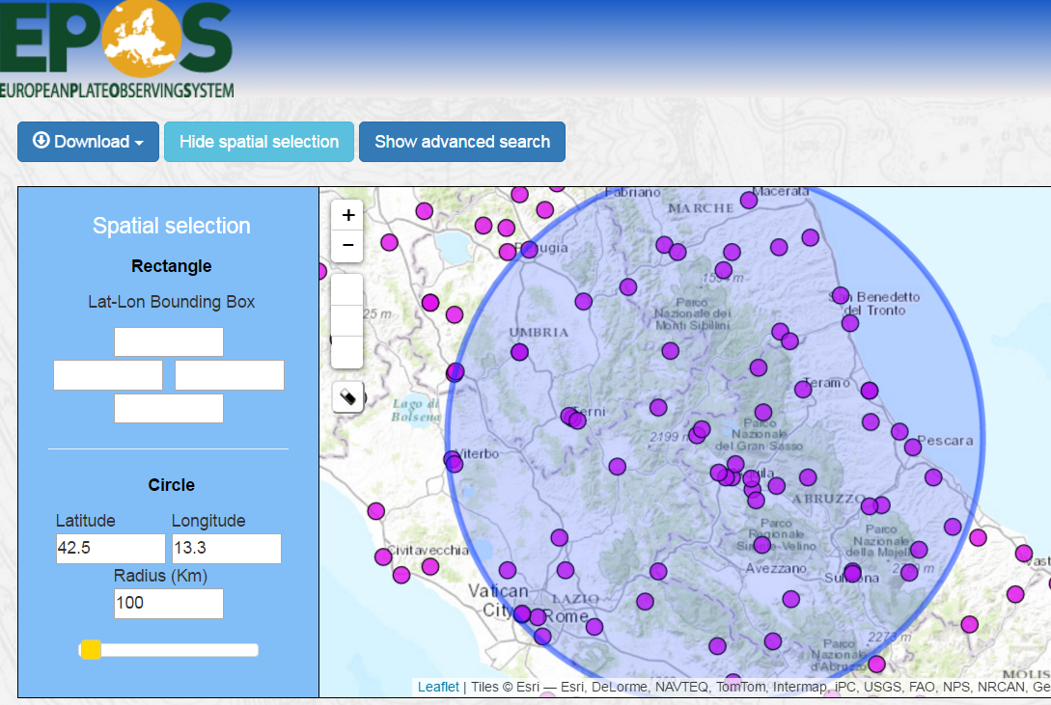

Using the GLASS API the EPOS ICS first harvested the necessary site and station metadata and then queried a WP10 test server containing a temporal dataset (station data and RINEX file MetaData). Results were returned to the EPOS Workspace and graphics representing a time series of the positions of particular stations was shown.

Within WP10 also attention has been paid to ensure interoperability with other international GNSS data provides such as the International GNSS Service (IGS) and the Plate Boundary Observatory (PBO). Therefore, within WP10 we are working to disseminate the GNSS metadata in GeodesyML which is a new international standard.

***The Current Status***

A completely new API has been developed. Requests of the same type were combined into one using meaningful path parameters. Also algorithms to retrieve data were improved and Correction and Performance Tests were Made. The current status of the DDSS’s is described in the following table.

|  |  |  |
| --- | --- | --- |
| **DDSS-ID** | **Name – web-service title** | **Is the web-service up and running?** |
| **WP10-DDSS-001** | EPOS Data Gateway/Portal  Provides Access to GNSS RAW DATA and metadata | This service deploys the Data GUI and Web Services and is Running.  GUI: http://glass.unice.fr:8080/epos_validation/#/site  Web Services: <http://glass.unice.fr:8080/GlassFramework/>  Operational |
| 001.a | Station Metadata | Disseminates metadata managed by DSSS-002 Operational |
| 001.b | RINEX File | Disseminates data from DDSS-004 and national repositories Operational |
| 001.c | RINEX file Quality Control information | Quality control of RINEX data Almost Operational |
|  |  |  |
| **WP10-DDSS-006** | EPOS Product Gateway/Portal  Provides Access to GNSS Products | This service deploys the Products GUI and Web Services and is Running.  GUI: <http://gnssproducts.epos.ubi.pt>  Web Services: <http://193.136.66.29:8102/GlassFramework>  Operational |
| 006.a | Station Coordinates | Disseminates data from DDSS-007, DDSS-008, DDSS-016 Operational |
| 006.b | Station Time-Series | Disseminates data from DDSS-009, DDSS-010, DDSS-014, DDSS-018 Operational |
| 006.c | Velocities/reference positions | Disseminates data from DDSS-012, DDSS-013, DDSS-014, DDSS-018 Operational |
| 006.d | Strain-Rates | Disseminates data from DDSS-017 Under Development |
| **WP10-DDSS-002** | Site/Station Submission Control Center | **Is not a web service**  It is a portal for centralized input of T1 station metadata.  <http://gnss-metadata.eu> (M3G):  **GUI works and on-line** ; T1 (in xml) are sent to data gateway.  Operational |
| WP10-DDSS-004 | Data Repositories /Providers.  GNSS Daily Data (30/15/1 second) | **Is not a web-service**  RINEX data  Interface to data gateway not yet ready (expected for M32)  Not operational yet through GLASS |
| WP10-DDSS-015 | GNSS positions and velocities Quality Monitoring | **Is not a web-service**  Station velocities  Station Time Series  Operational |
| WP10-DDSS-019 | Software to Access to data/products | **Is not a web-service**.  Available at https://gitlab.com/gpseurope/  Associated documents: see annex 1  Operational – Not all GLASS components available |

Table : Status of High-Priority TCS10 DDSS accessible via Web Services

WP10 Web Services have been described in the EPOS DCAT XML FILE, the attribute <eposap:DDSS-ID> relates WS to DDSS.

***Other Relevant Points***

* AAAI services for user’s registry and secure data access;

Google analytics is being used at some of the portals to monitor the USER interaction with the Portal.  
The underlying API calls are not yet monitored.

* Workflows and computational services;  
  No-one in our TCS uses workflow management systems
* ICS-D  
  No-one in WP10 TCS is currently using distributed computing services. In the future it is envisaged to have on demand computation of strain rate maps that will use distributed computing services.
* Other services for data visualization, processing, etc   
  The portals have some basic visualization options (time series, photos of GNSS stations, maps with station location, etc.)
* Software Distribution

WP10 Software will be distributed as Source Code (gitlab) as well as pre installed Virtual Machines (Virtual Box) and (in the future) as Docker Containers.

# 6. Conclusion

This document reports the current accepted list of DDSS’s that will be managed by the GNSS EPOS-TCS in the future during EPOS-OP. The number of DDSS’s are relatively reduced since it was an option of the partners to concentrate on the ones that are considered essential to be used by the scientific community related with Solid Earth.

Currently prototypes for most of the DDSS’s within the EPOS partners, including EUREF are being finalized. The EPOS Demonstrator shown during the Prague conference has showcased the current maturity of the DDSS implementations. The implementation of these services will also permit the development of further Use Cases and to better define further requirements.

1. Fully operational but not yet integrated in the GNSS-EPOS: they will operate the GLASS software (WP10-DDSS-019) to make these data discoverable to the GNSS data gateway (DDSS-WP10-001).
2. Main components (Portals; API) ready. Some components still in development